|  |  |
| --- | --- |
|  |  |
| Name: Basem Ashraf Hamdy B.N:239  Topic: operating system  GitHub link: https://basemashraf110.github.io/basemashraf110/  GitHub page: https://github.com/basemashraf110  Application brief:  What is an Operating System? An Operating system (OS) is a software which acts as an interface between the end user and computer hardware. Every computer must have at least one OS to run other programs. An application like Chrome, MS Word, Games, etc needs some environment in which it will run and perform its task. The OS helps you to communicate with the computer without knowing how to speak the computer's language. It is not possible for the user to use any computer or mobile device without having an operating system. As long as each application accesses the same resources and services in the same way, that system software -- the operating system -- can service almost any number of applications. This vastly reduces the amount of time and coding required to develop and debug an application, while ensuring that users can control, configure and manage the system hardware through a common and well- understood interface. Once installed, the operating system relies on a vast library of device drivers to tailor OS services to the specific hardware environment. Thus, every application may make a common call to a storage device, but the OS receives that call and uses the corresponding driver to translate the call into actions (commands) needed for the underlying hardware on that specific computer. Today, the operating system provides a comprehensive platform that identifies, configures and manages a range of hardware, including processors; memory devices and memory management; chipsets; storage; networking; port communication, such as Video Graphics Array (VGA), High-Definition Multimedia Interface (HDMI) and Universal Serial Bus (USB); and subsystem interfaces, such as Peripheral Component Interconnect Express (PCIe). |  |
|  |  |

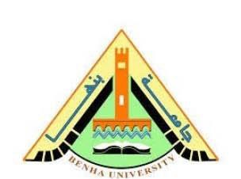

|  |  |
| --- | --- |
|  |  |
| **Benha University Faculty of Engineering - Shoubra**  **Academic year 2019-2020**  Types of Operating system: Batch Operating System-Multitasking/Time Sharing OS - Multiprocessing OS- Real Time OS -Distributed OS -Network OS -Mobile OS.  The advantage of using Operating System: (Allows you to hide details of hardware by creating an abstraction -Easy to use with a GUI -Offers an environment in which a user may execute programs/applications)  **Screen shots :**  **1 |** P a g e |  |
|  |  |

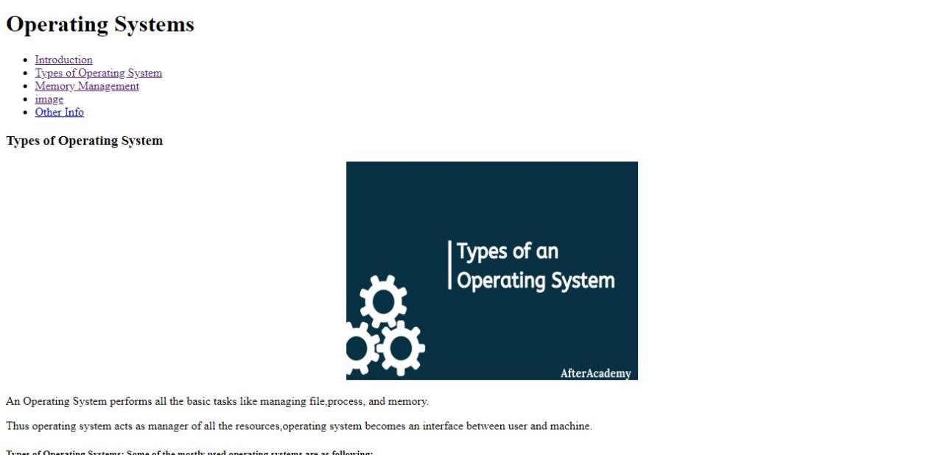

**2 |** P a g e

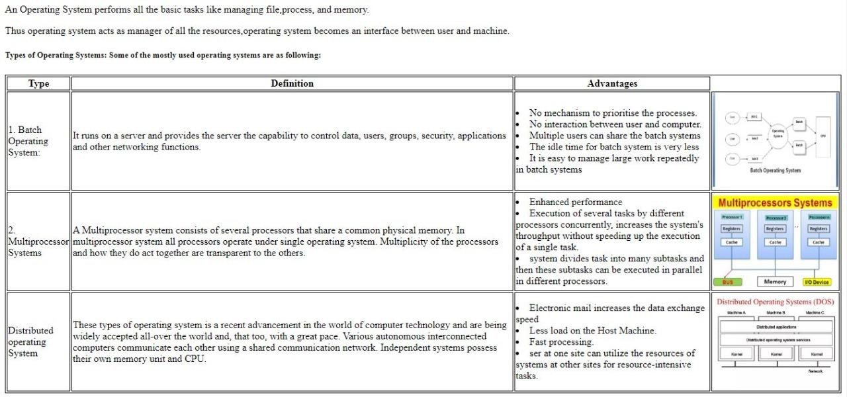

Benha University Faculty of Engineering - Shoubra

Academic year 2019-2020

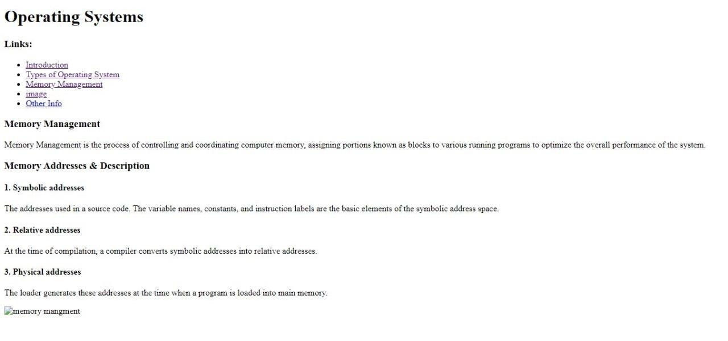

**3 |** P a g e

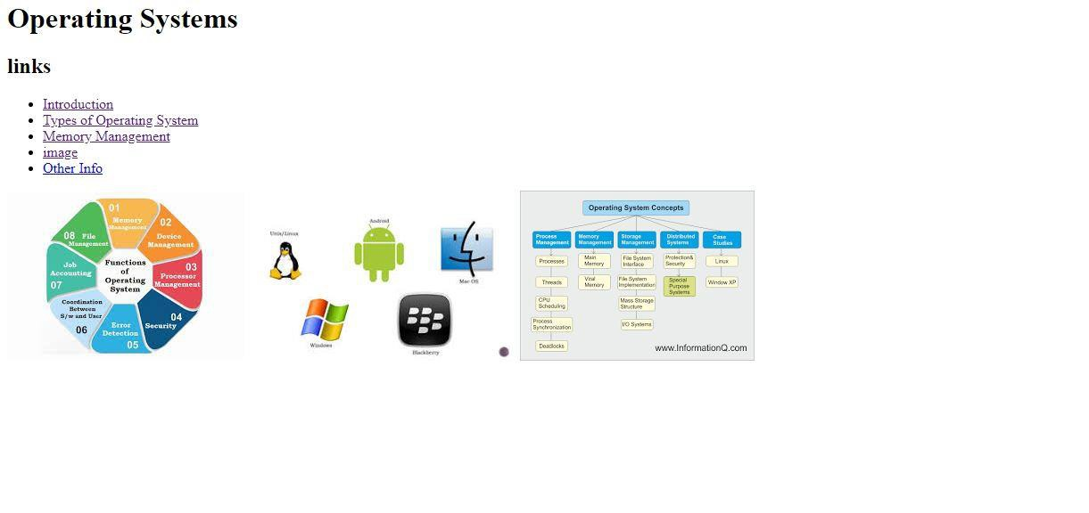

Benha University Faculty of Engineering - Shoubra

Academic year 2019-2020

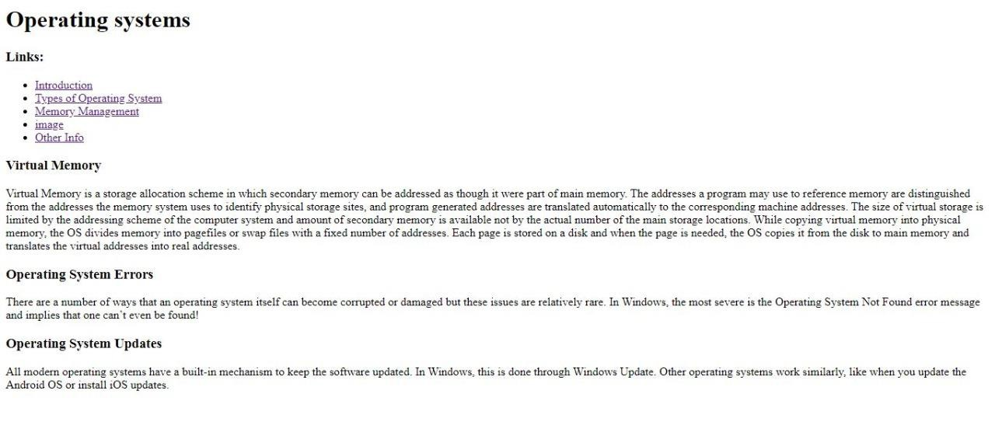

**Screen code:**

Benha University Faculty of Engineering - Shoubra

Academic year 2019-2020

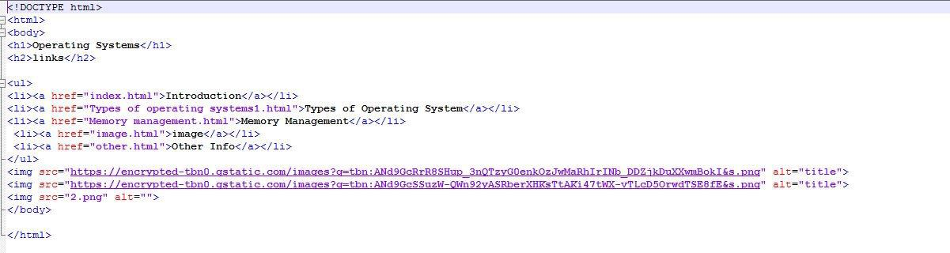

1. **|** P a g e

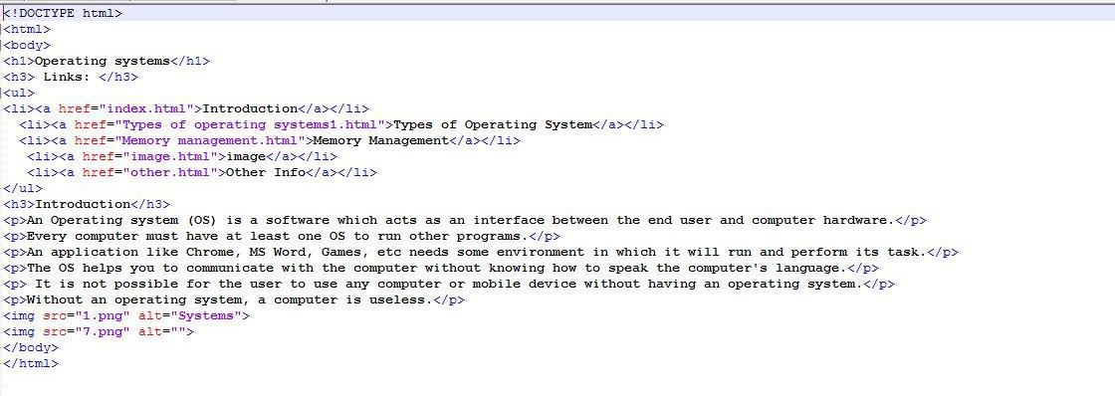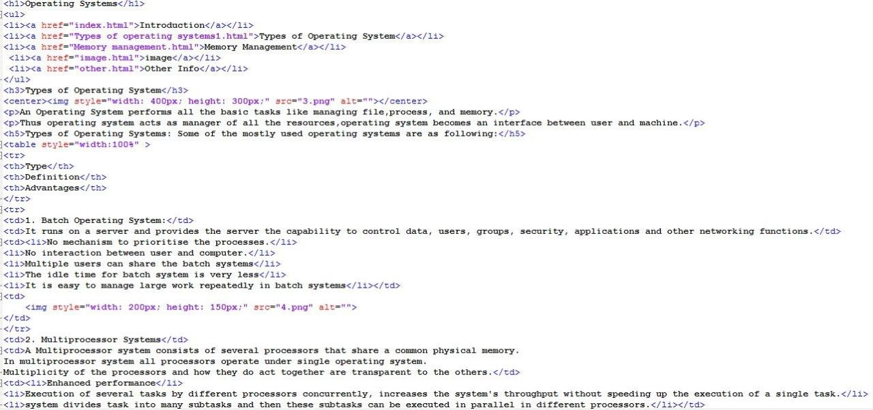

1. **|** P a g e

Benha University Faculty of Engineering - Shoubra

Academic year 2019-2020

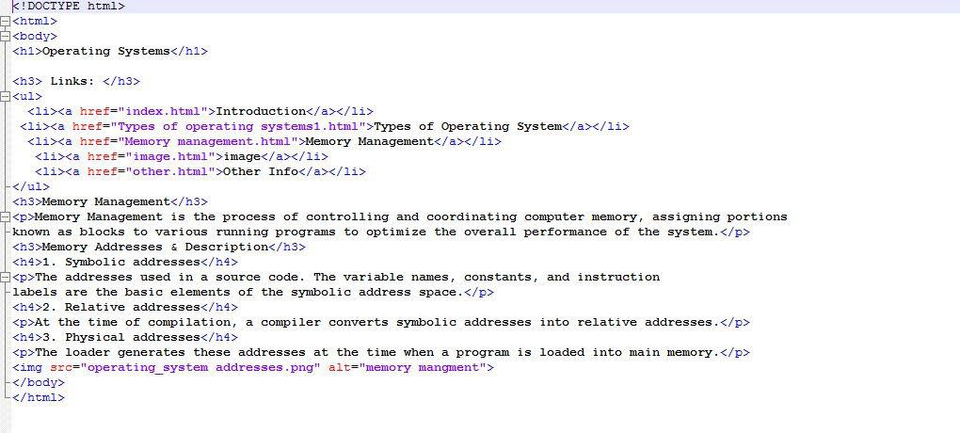

1. **|** P a g e

Benha University Faculty of Engineering - Shoubra

Academic year 2019-2020